Exercise

1.

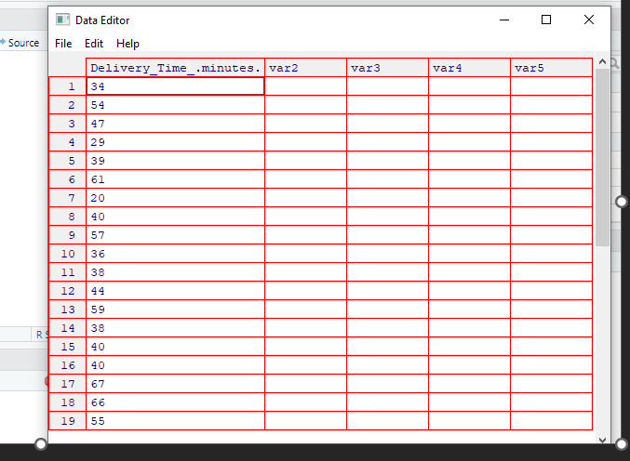

2.

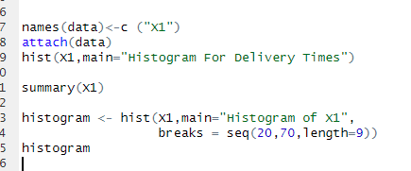

3.

Bi-Model shaped

4.

